Derrick Fox

CS 136

June 28, 2014

Week 5

Week 5

1. Prepare a context diagram for the new system.

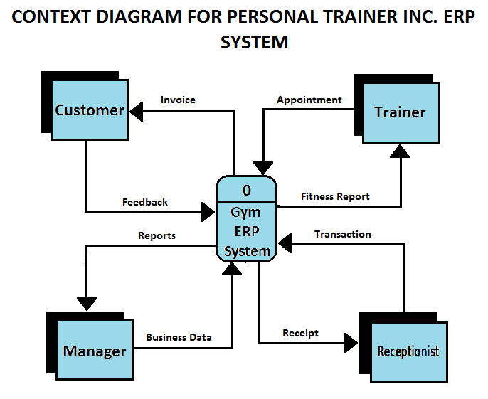

2. Prepare a diagram 0 DFD for the new system.

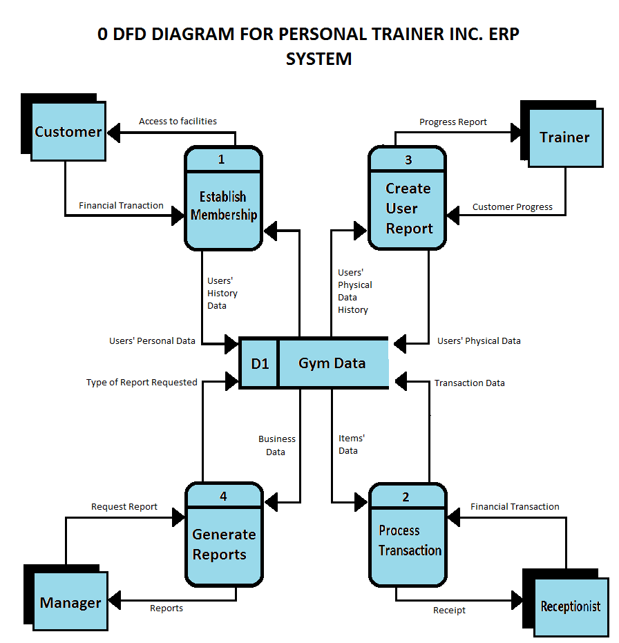

3. Write a brief memo that explains the importance of leveling a set of DFDs.

Leveling our DFD diagrams is important to our project because it illustrates every process down to the most granular single processes or function primitives. By doing this, we can ensure that we have incorporated all functions necessary for the system to operate properly. The lowest level DFD will depict all of the most granular function primitives and all of the parent DFDs will help to conceptualize how those individual processes interact with the system as a whole. Also, this approach helps to modularize the system which could aid in the development process.

4. Write a brief memo that explains the importance of balancing a set of DFDs.

By balancing our DFDs we can ensure that every data flow of the parent DFD is maintained on the child DFDs. In this way we can see visually that every input and output is accounted for and that there are no lose ends. If the system adheres to sound principles of system design then it will be balanced in the DFD. If not, the balancing of the DFDs could help to shine a light on a potential system discrepancy before implementation.